11/24 Holyrood Street
Hampton, Vic 3188
Phone: 0423 121 711
23rd November 2023

To Whom it May Concern

I have had the pleasure of knowing Fran Kelly and Gus McKinstry for over ten years. Together they are the musical duo Amazon Blue. In my previous role as Product Manager Small Ship Cruising at APT (Australia Pacific Touring) I engaged Amazon Blue to perform on our various cruise ships around the world.

I found their music very entertaining for our travellers. They offer a huge song list that is adaptable to whatever the situation requires: dancing, easy listening, pre-dinner, or stage show to name just a few. I found them to be the complete entertainment package. Being able to travel and be self-contained and flexible was an ideal fit for our products and requirements.

Where they excel is the way they engaged with our guests – they were far more than just a musical act. Fran & Gus would interact with passengers throughout the day, helping with ship logistics, embarkation and providing unforgettable moments that were not traditionally part of the musician’s role. They displayed a consistent and always available work ethic that was highly commendable.

The other strength of Amazon Blue was that they were the complete entertainment package – they could run quizzes on a variety of subjects, games events, karaoke, and all manner of shows to provide a comprehensive varied program on a small ship cruise. This is a talent and skill I am sure would transfer equally successfully to a hotel or resort dealing with longer stay guests looking for variety.

As people, I can’t recommend them enough, honest, friendly, reliable, engaged team players are descriptions that easily come to mind. They are great ambassadors and representatives of any business they work for. They are genuine good employees.

Please don’t hesitate to contact me at craigjames4@bigpond.com or 0423 121 711 with any questions or if you would like to discuss Fran & Gus further.

Kind Regards,

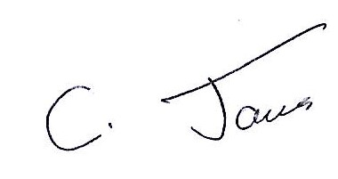

Craig James

